**S1 Accession No**

The supporting materials S1 includes; 7 species of Vespaidae: *Vespa mandarinia* (XP_035737952.1), *Vespa crabro* (XP_046824901.1), *Vespa velutina* (XP_047357593.1), *Vespula vulgaris* (XP_050858048.1), *Vespula pensylvanica* (XP_043673380.1), *Polistes dominula* (XP_015177827.1), *Polistes fuscatus* (XP_043495209.1); 17 species of Bee family: *Bombus vancouverensis nearcticus* (XP_033205116.1), subgenus *Bombus huntii* (XP_050473413.1), *Bombus impatiens* in eastern America (XP_003491527. 1), *Bombus terrestris* (XP_003394698.1), *Bombus ignitus* (8EW5_A Chain A), *Apis dorsata* (XP_006618153.1), *Apis florea* (XP_003696584.), *Apis laboriosa* (XP_0437) 92750 .1), *Apis mellifera caucasica* (KAG6799352.1), *Apis cerana* (XP_016912210.1), *Megachile rotundata* (XP_003706340.1), *Melipona quadrifasciata* (KOX67587.1), *Frieseomel ittavaria* (XP_043521843. 1), *Habropoda laboriosa* (XP_017790128.1), *Colletes gigas* (XP_043257386.1), *Osmia lignaria* (XP_034180962.1), *Ceratina calcarata* (XP_017884125.1); Formicidae 13 Species: *Camponotus floridanus* (XP_011267943.1), *Monomorium pharaonis* (XP_012533138.1), *Pogonomyrmex barbatus* (XP_011629524.1), *Dinoponera quadriceps* (XP_014479977.1 ), *Harpegnathos saltator* (XP_011154535.1), *Odontomachus brunneus* (XP_032685464.1), *Acromyrmex echinatior* (XP_011064338.1), *Pseudomyrmex gracilis* (XP_020284828.1), Spain Arrow ant *Cataglyphis hispanica* (XP_050455871.1), *Formica exsecta* (XP_029672853.1), *Nylanderia fulva* (XP_029155503.1), *Solenopsis invicta* (XP_011171429.1), *Temnothorax longispinosus* (TG Z32040.1 ).

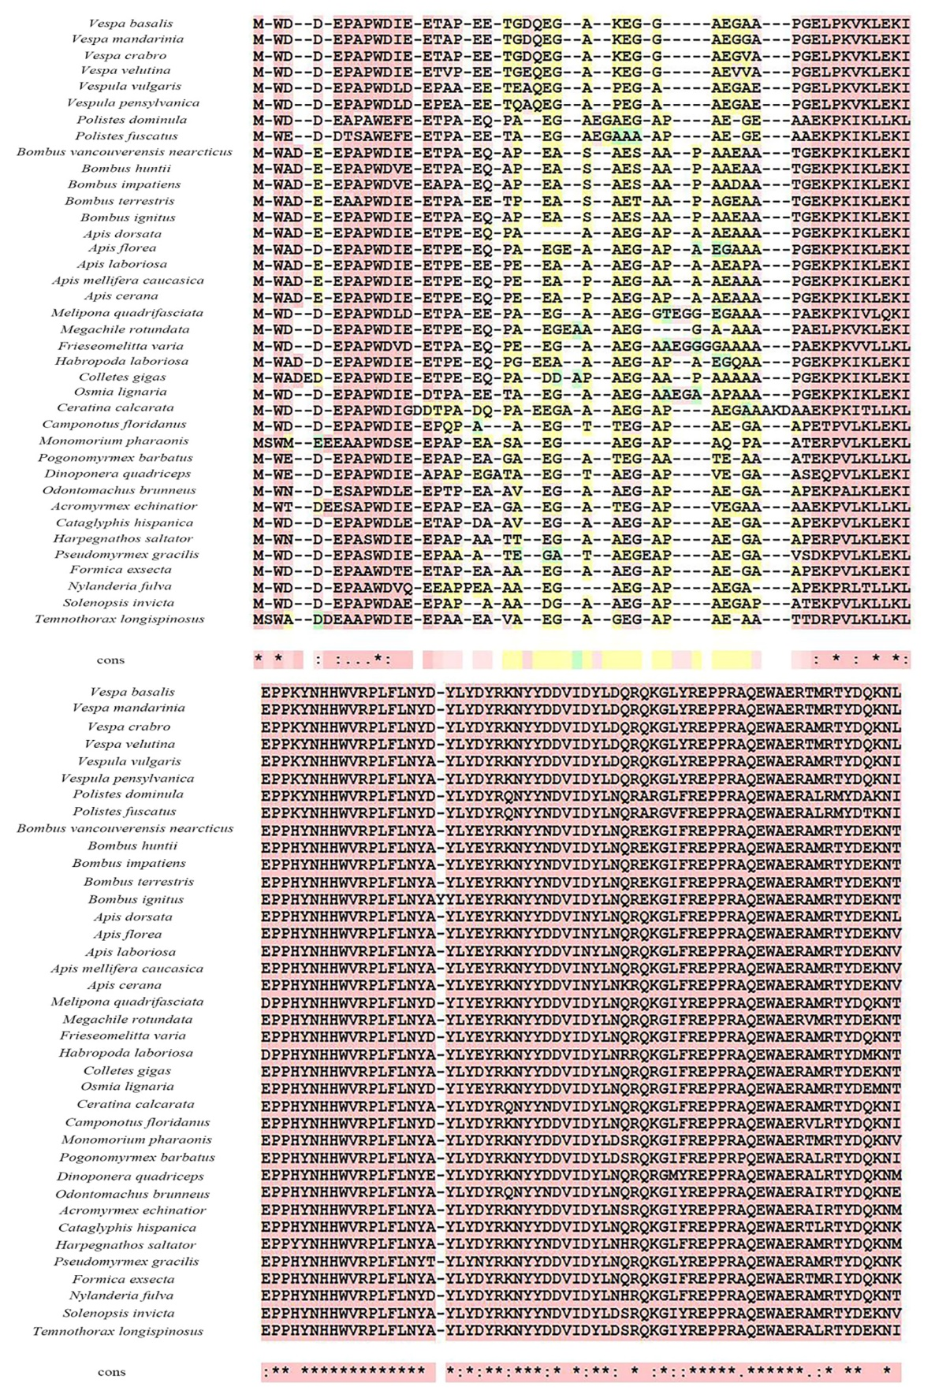

Figure S2. Protein Homology

Reedy, M. C., Bullard, B., & Vigoreaux, J. O. (2000). Flightin is essential for thick filament assembly and sarcomere stability in Drosophila flight muscles. The Journal of cell biology, 151(7), 1483-1500.

Schmitz, S., Schankin, C. J., Prinz, H., Curwen, R. S., Ashton, P. D., Caves, L. S., ... & Veigel, C. (2003). Molecular evolutionary convergence of the flight muscle protein arthrin in Diptera and Hemiptera. Molecular biology and evolution, 20(12), 2019-2033.

Josephson, RK (2006). Comparative physiology of insect flight muscle. Nature's versatile engine: Insect flight muscle inside and out , 34-43.

Qiu, F., Brendel, S., Cunha, PM, Astola, N., Song, B., Furlong, EE, ... & Bullard, B. (2005). Myofilin, a protein in the thick filaments of insect muscle. Journal of cell science, 118 (7), 1527-1536.

Ayme-Southgate, AJ, Southgate, RJ, Philipp, RA, Sotka, EE, & Kramp, C. (2008). The myofibrillar protein, projectin, is highly conserved across insect evolution except for its PEVK domain. Journal of molecular evolution , 67 , 653-669.

Schöck, F., & González-Morales, N. (2022). The insect perspective on Z-disc structure and biology. Journal of Cell Science, 135(20), jcs260179.

Ayme-Southgate, A., Feldman, S., & Fulmer, D. (2015). Myofilament proteins in the synchronous flight muscles of Manduca sexta show both similarities and differences to Drosophila melanogaster. Insect biochemistry and molecular biology, 62, 174-182.

Iwamoto, H. (2011). Structure, function and evolution of insect flight muscle. Biophysics, 7, 21-28.

Marden, J. H. (2000). Variability in the size, composition, and function of insect flight muscles. Annual Review of Physiology, 62(1), 157-178.

Josephson, R. K. (2006). Comparative physiology of insect flight muscle. Nature’s versatile engine: Insect flight muscle inside and out, 34-43.